# Week 5: 2D Drawings

|  |  |
| --- | --- |
| **Concepts** | * An introduction to engineering drawings * Creating drawing views, dimensioning, tolerancing, notes * Using formats/templates * Introducing GTOL/GD&T |
| **Models** | * Simple models from Week 2 * Assembled Vise |
|  | |

# 

# Before we get started…

# A note about Drawings in Onshape

**Engineering Drawings** (also known as Prints, for when they are actually printed) are a vital part of the Product Development process. It is critically important to document our designs in a clear and concise manner, such that the original design intent is communicated to others. Engineering Drawings are meant to be shared - with others on the team, such as suppliers and partners, immediate teammates and management, manufacturers and assemblers, and in some cases the customer as well. In its simplest form, an Engineering Drawing is a 2-D document that is used to explain to manufacturing how to make a part or assembly.

It is very important to learn how to create a “good” drawing, but first we must define what “good” means. Let’s say that we want to manufacture the part we made in Week 2:

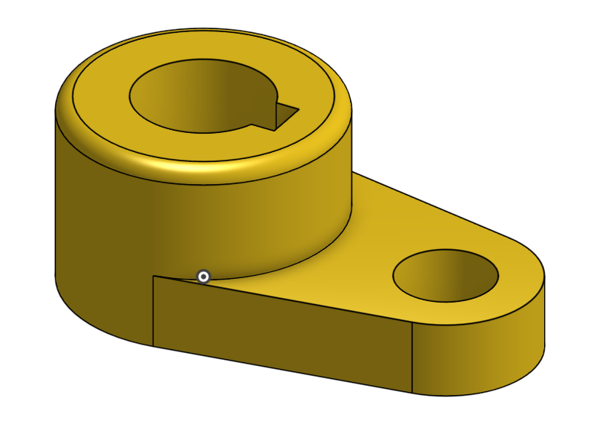

How do we communicate the part’s dimensions accurately to the manufacturers? We need to be able to fully communicate the dimensions of the holes, the height of the extrusions, the fillet radius, etc., in a clean and efficient way. Of course, adding the base sketch (picture to the left below) helps to communicate how the part looks like from the Top view (right):

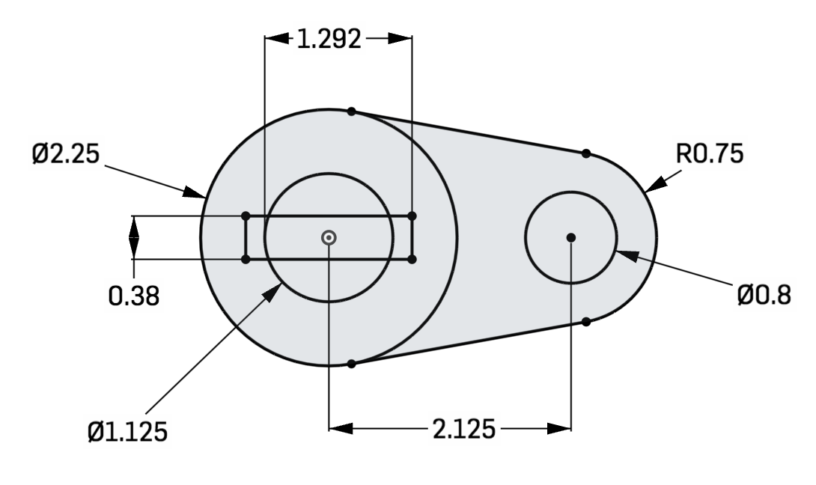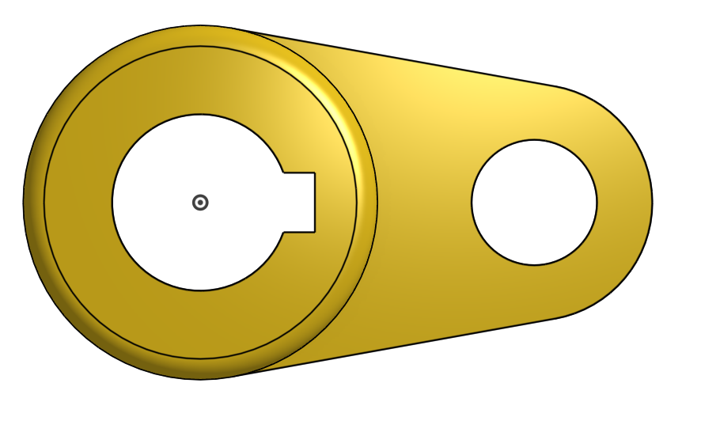

But sometimes, even presenting the 2D sketches that make the part isn’t enough. Notice that the base sketch doesn’t exactly correspond with the Top view of the final model; the bigger hole is modified, and the part is filleted. We somehow need to combine the information provided by the two images above. This is where Engineering Drawings come in play.

Many companies and industries have their own standards and best practices, which we will not try to cover here. Instead, we will focus on creating drawings which are easy to read, organized, have a good use of space on the sheet, and are consistent. Professional designers and engineers will agree that creating a “good” drawing is as much an art as it is a science. Here is an example of an Engineering Drawing of our example part (annotations in blue are not part of the Drawing, but we added them to label some key features):

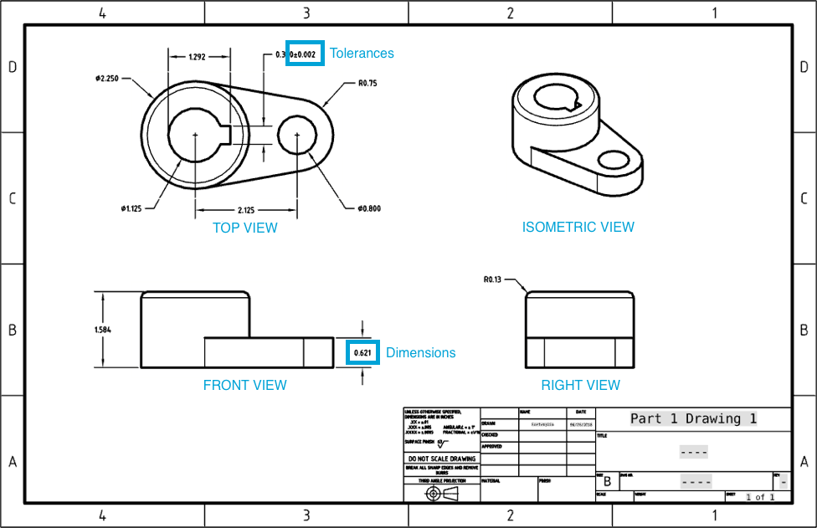

We’ll be making this drawing in our first exercise. Since Engineering Drawings are a communication tool, you can think of the information on them as a language. Engineering Drawings usually have standard information such as the Drawing Format, geometry from different views (Top, Isometric, Front, and Right etc.), dimensions, and tolerances. With enough information, any manufacturing company should be able to make the exact same part just by looking at the Engineering Drawing.

In an effort to standardize how this information is communicated, there are numerous standards organizations across the globe such as ASME (in the U.S), ISO (in Europe), DIN (in Germany), and JIS (in Japan). For the Onshape College curriculum, we will focus on creating drawings according to the ANSI standard. More specifically this curriculum will reference ASME Y14, within which are numerous standards to define how an engineering drawing should look. More info can be found at [www.asme.org](http://www.asme.org).

Due to the advancement of these standards and the global use of 3D CAD software, it is becoming more and more common to communicate to each other by just sharing a 3D CAD file. It can’t get any easier in Onshape, where you can share the original CAD Design in its native, parametric format! However, despite many industries moving away from using 2-D Engineering Drawings, there are still many engineering and manufacturing firms who depend on them to do business. Perhaps, at some point in the future 2-D drawings will become obsolete, but until then it is very important to discuss the process of creating high quality engineering drawings.

Before proceeding, it would be very helpful to review the Onshape specific procedures in the Onshape help documentation on drawings here: <https://cad.onshape.com/help/#drawings>.

# Creating Drawings & Dimensions

## In-Class Exercise #1:

Using some parts we’ve already modeled in previous lessons, we’re going to create several drawings using a variety of views, dimension schemes, and tolerances:

1. Let’s start with [Part 1 from Week 2](https://docs.google.com/document/d/1NYEj1zOaYX65oQZEZtx-_fqIDtXTgUXqXU_JkwFdm1g/edit#bookmark=id.1zhj469efx20). Right-click on the Part Studio Tab and select “Create drawing of Part 1…”. The following screen will pop up, asking for a template, and select the ANSI_B_INCH template with Four views, and hit [OK]:

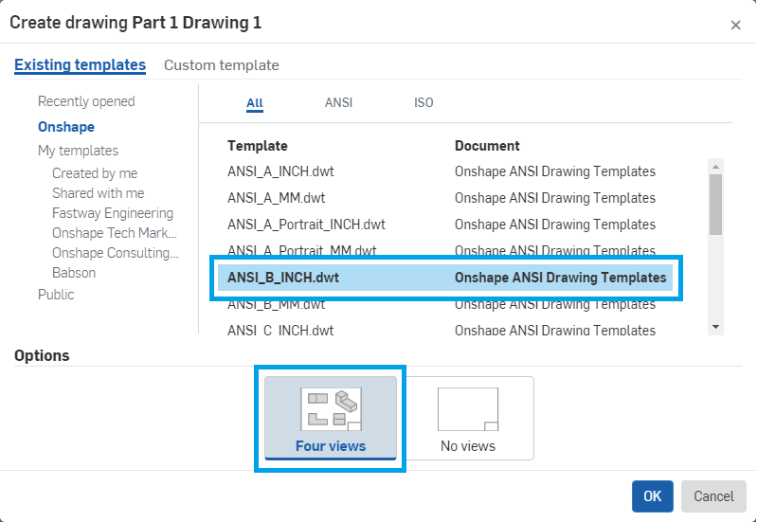

*Pro Tip: The “Four Views” layout is a very common layout for engineering drawings, which is why it is offered here as a shortcut. (It is only available by using this “Right Click” shortcut). When selected, it automatically populates the drawing with Four commonly used views. The views are, starting with the top-right and going clockwise, Isometric, Right, Front, and Top. Most simple mechanical parts can be dimensioned using the Front, Top, and Right views, and it is common practice to provide an Isometric view for reference as well.*

1. Now we have a new drawing, and notice we have a new toolbar across the top as well. Take some time to hover over each button and read the description. From left to right the tool sections cover Views, Dimensions, Geometric Tolerancing, Annotations, and Reference Geometry:

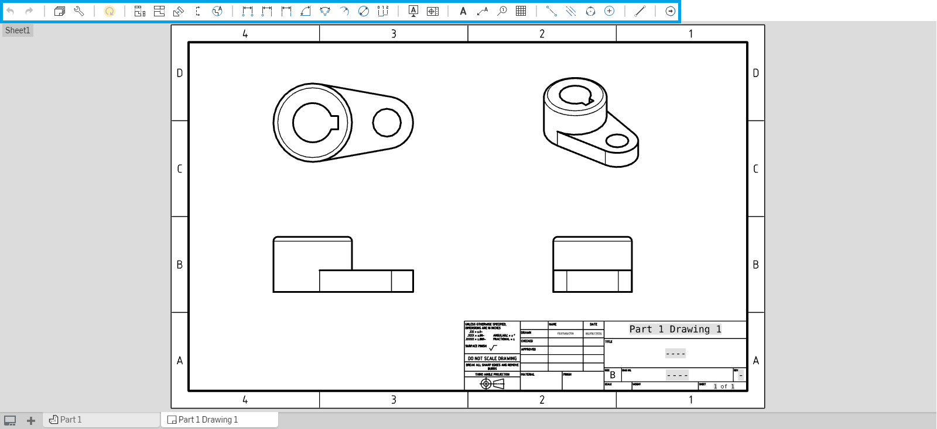

1. Let’s start by creating dimensions in the front view (in the lower-left corner). Select the 2-point linear dimension . Then select the two points as shown, followed by a third point to place the dimension (this is a similar workflow when creating a dimension within a sketch in the part studio):

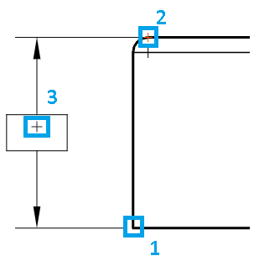

1. Once placed, the dimension value should be shown like this:

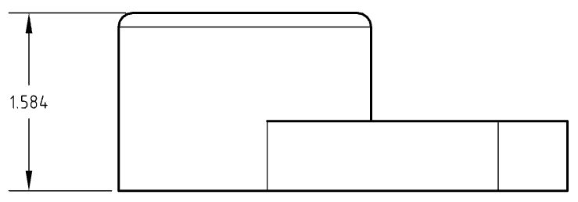

1. Let’s create another height dimension on the right side:

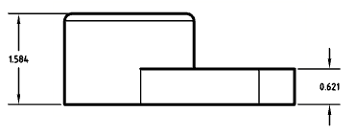

1. Next, we’ll need to add some reference geometry to the top view for dimensioning. Select the centermark tool, , and select each circle in the view. The “+” sign will appear in the center of each circle:

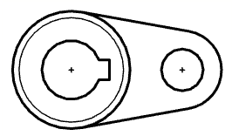

1. Now, let’s create a dimension between the centermarks using the 2-point linear dimension again:

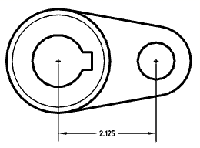

*Pro Tip: If you made a mistake, you can always select the dimension and press* ***delete*** *to get rid of the dimension.*

1. Next, let’s add the diameter dimensions for the holes using the Diameter dimension tool, :

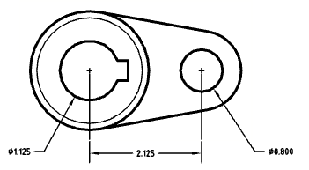

*Pro Tip: Notice how the diameter dimensions are lined up with the horizontal dimension. You can do this by “waking up” the inference, similar to the way you did in sketching. Before placing the dimension, hover over the dimension you want to align. Several snap points will appear in red as you hover:*

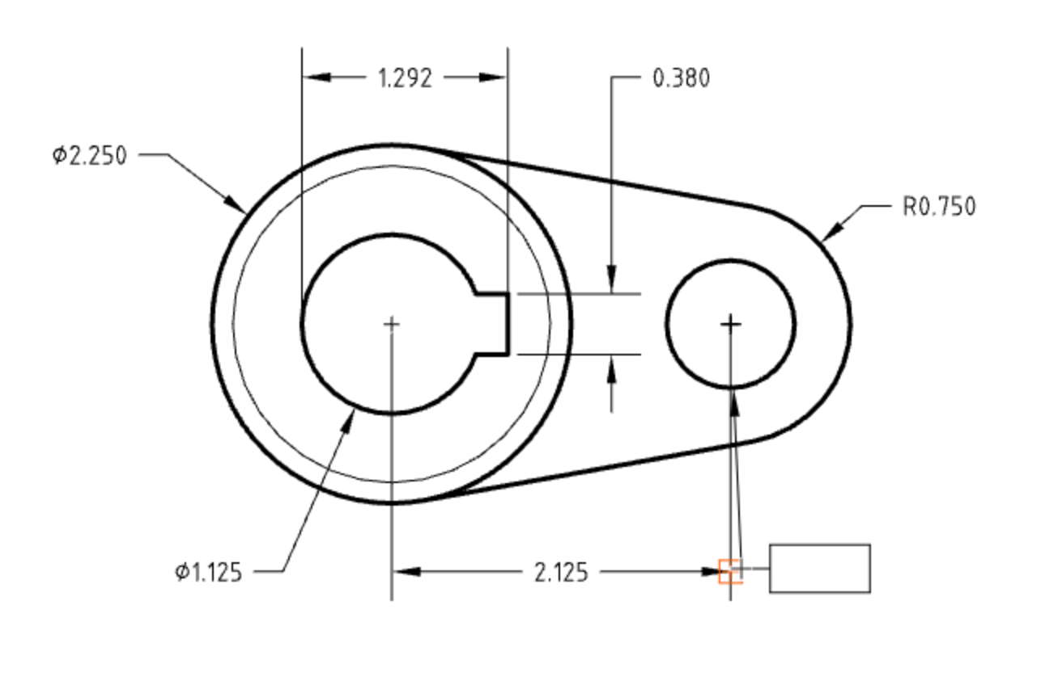

*Drag away from the snap point and a dotted horizontal line should show up. The dotted line and the red crosses tell you that your dimensions are now horizontally aligned:*

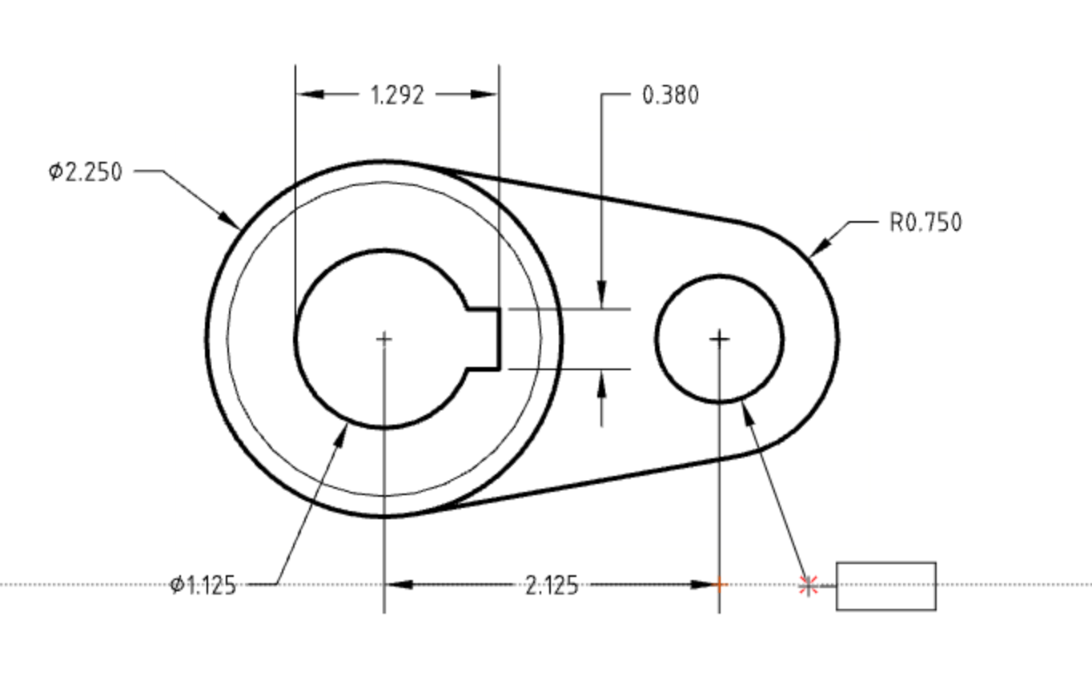

*This is done on purpose, so it is easy to read. In this case, these three dimensions reference the same geometry, so aligning them makes it easy for the reader to comprehend quickly. Small details like this can prevent miscommunication, therefore saving you time and money in the machine shop! However, note that once the dimension is made and subsequently dragged around, you cannot align it.*

1. Next, let’s add dimensions for the keyway, again aligning the dimensions as we go:

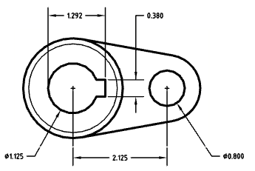

*Pro Tip: There are multiple ways in which we could have dimensioned the keyway, but the method above is preferred, as it is the easiest to measure. This can save time and money during measurement and inspection processes!*

1. Next, let’s add the diameter dimension to the large boss:

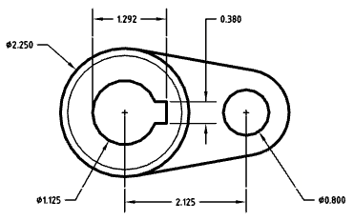

1. Next, let’s add the Radius dimension  on the right side. We use the radius here, instead of the diameter dimension, because it is not a full circle:

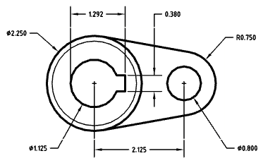

# Tolerances

1. Let’s change the number of decimal places on the R0.750 from three to two. Make sure you are not in another tool (the [Esc] key will exit any tool you are in), and select the dimension:

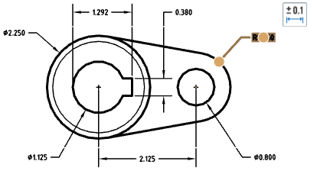

1. A tolerance icon pops up, now hover over that to expose the Dimension Panel. In engineering, the tolerance states how much variation in dimension is allowed during manufacturing:

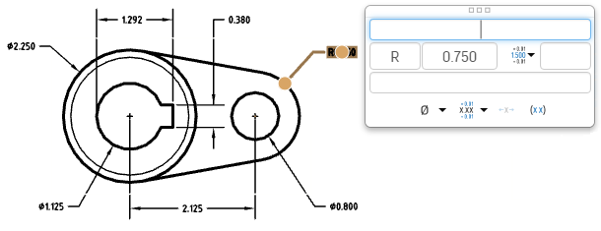

1. Pull down the “Precision” icon,, and select 2 decimal places:

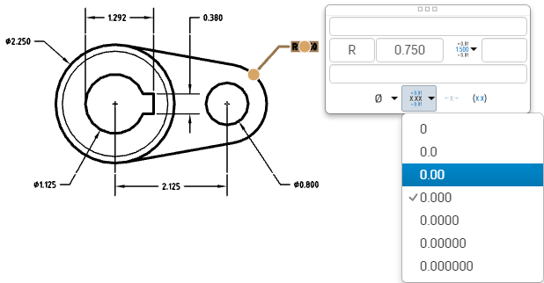

1. Click anywhere outside the dialog box to exit out of it. This final dimension should look like this now:

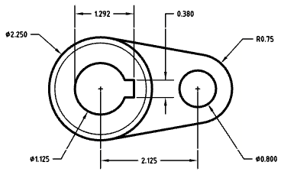

*Pro Tip: Removing the “zero” in the third decimal place might seem like an insignificant change, but it has a very significant impact. Let’s inspect our drawing format a little more closely. In the bottom right corner of the format is our title block, and in it is a list of the drawings “standard tolerances”:*

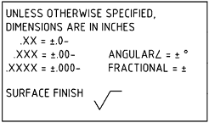

*Here we state the standard tolerances for linear and angular dimensions, and surface finish. Focusing on the linear tolerances (left side), we see that there is a specific tolerance associated to a dimension. Depending on how many decimals it has, the tolerance changes. Generally speaking, the more decimals a dimension has, the smaller (“tighter”) the tolerance. Let’s add values to our tolerance block as shown. Double clicking will allow the values to be updated. Let’s use these typical machining tolerances:*

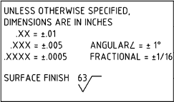

*Now, changing the number of decimals on our dimensions means something! Updating our radius dimension from “R0.750” to “R0.75” actually changes the tolerance from +/- .005 to +/- .01. Since this radius is on the outside of the part, it is not that critical to its performance, and so we have communicated that. As a designer, any time we can make the tolerance larger (commonly referred to as “opening up” the tolerance) we should, because that will almost always make the part cheaper and easier to manufacture. At the same time, if there is a particular feature that is very critical to the parts function or performance, we may want to make the tolerance smaller (also known as “tightening it up”).*

1. Keyways are typically very important features, so let’s communicate that by tightening up the tolerance on our keyway. In this case, let’s get practice by adding a specific tolerance. Click the 0.380 dimension, and hover over the tolerance icon. Pull down the “Tolerance” icon, and select “Symmetric”:

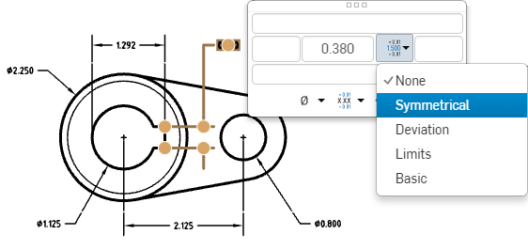

1. Now, let’s tighten the dimension up to +/- .002:

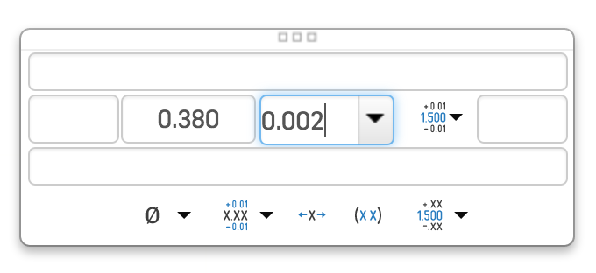

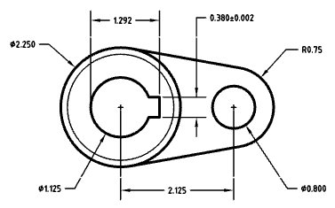

*Pro Tip: Symmetrical Tolerances are the most commonly used ones, because they are very straight forward - it’s like saying, “Try to build this part to the nominal dimension shown, but you may be off an equal amount in either direction”. Again, this works in most situations, but there are several other choices we can use when we are communicating the tolerance of our dimensions. Here is a short description of those other choices:*

*Deviation: This allows you to type in asymmetrical tolerances. For example, a popular application is shown below, which is like saying, “The nominal dimension is .380”, but if you’re going to be wrong, it can’t be any larger, it can only be less by .005” at the most.”*



*Limits: This allows you to just type in the limits of the tolerance band. This is used when you want to say something like, “I don’t care what this dimension is, as long as it is between .385 and .375., inclusive”*

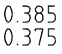

*Basic: This strips all tolerances away from the dimension, therefore it may only be used in conjunction with a Geometric Dimensioning & Tolerancing (GD&T) Feature Reference Frame. We will discuss GD&T a little bit later but for now, it is important to know it is here. Graphically, the dimension is surrounded by a rectangle:*



1. The top view is now complete, so let’s add the final dimension to the drawing in the Right view (bottom right of sheet). Add a radius dimension to the fillet. It is not a critical feature, so it should only be two decimal places.

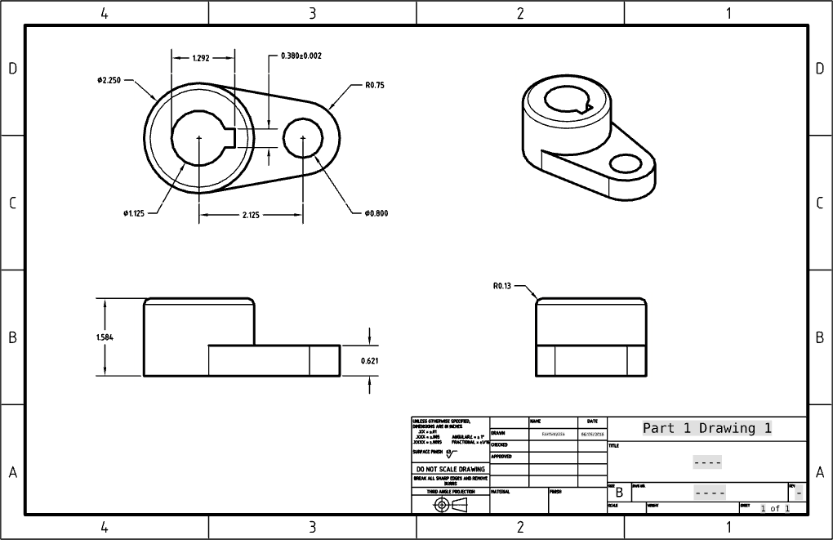

1. Congratulations, you’ve finished your first Engineering Drawing in Onshape!

# Projected & Section Views

## In-Class Exercise #2:

Let’s create another drawing, but with a slightly different approach.

1. Start by creating a new drawing directly from within Onshape, by selecting the “+” in the bottom left corner of the screen:

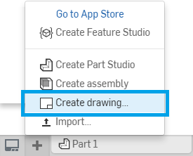

1. Select the ANSI_B_INCH template, and select [OK]. Note that this time, you can only choose “No views”. There should now be an empty drawing in the background, and Onshape is looking to insert a part or assembly. Let’s browse to [Part 2 from Week 2](https://docs.google.com/document/d/1NYEj1zOaYX65oQZEZtx-_fqIDtXTgUXqXU_JkwFdm1g/edit#bookmark=id.27js328ourbo). Once selected, Onshape will ask us to place a view. By default it is the Front view, change it to the Right View, and place it on the sheet as shown:

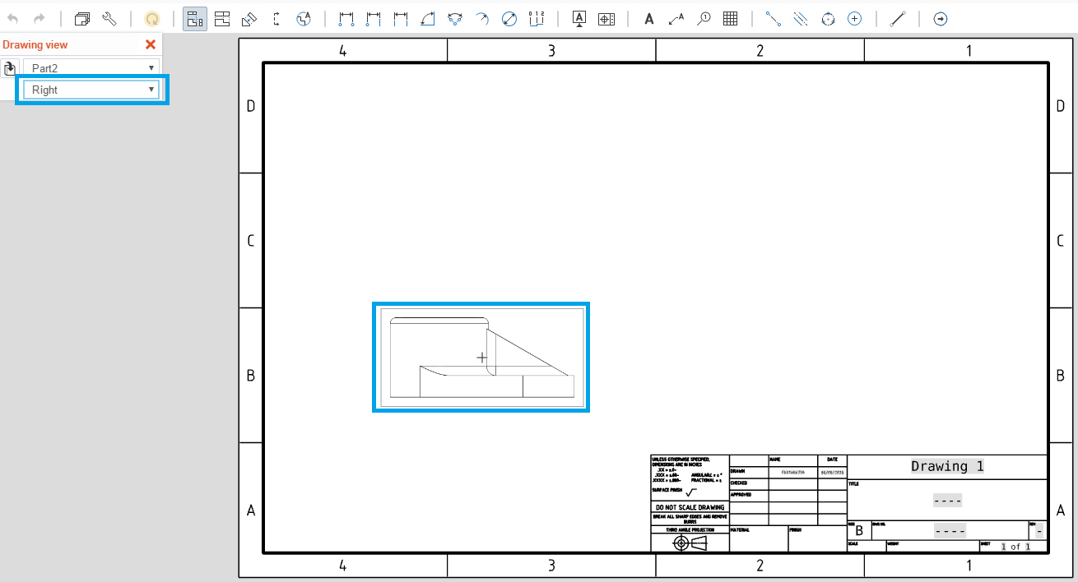

1. Now, let’s add a projected view above it. Select the projected view icon  and click on the existing Right view that you just placed. Then click on the screen just above it (if you hover directly above the existing Right view long enough, a preview of the Top view will show up):

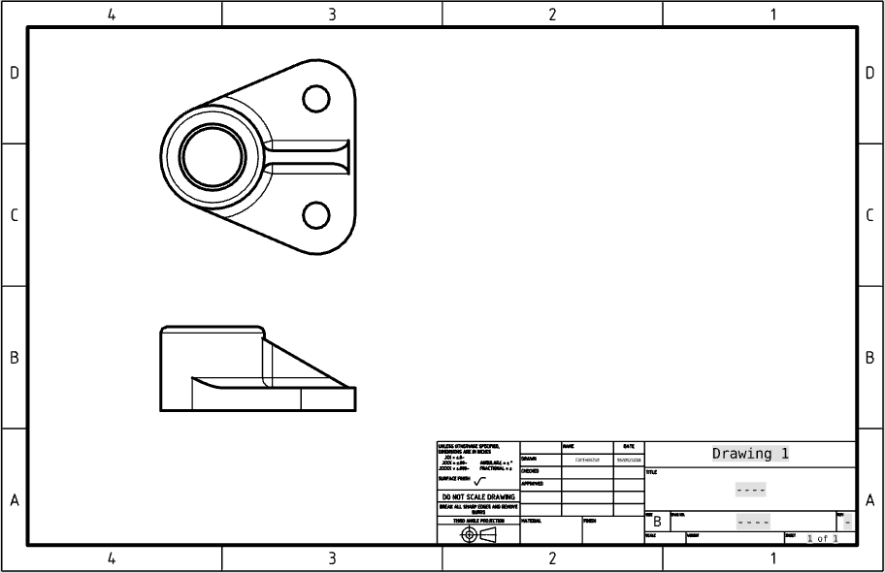

1. Let’s add another projected view just to the right of the first view. This time, let’s use a different method. Right-Click on the First view, and select “Create Projected View”:

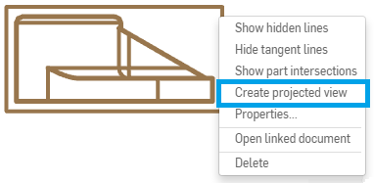

1. Place the view just to the right of the first view:

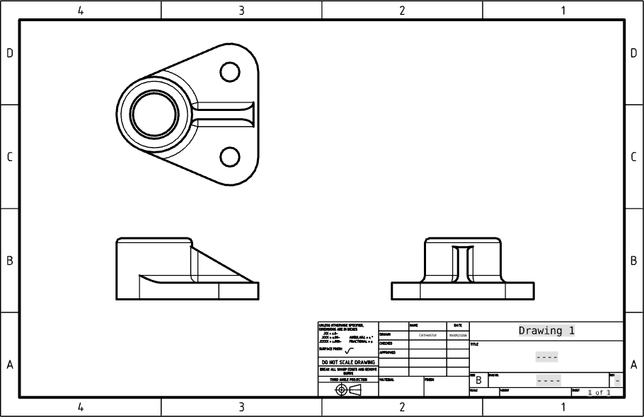

1. Finally, create an isometric view, by projecting the first view up towards the top right corner:

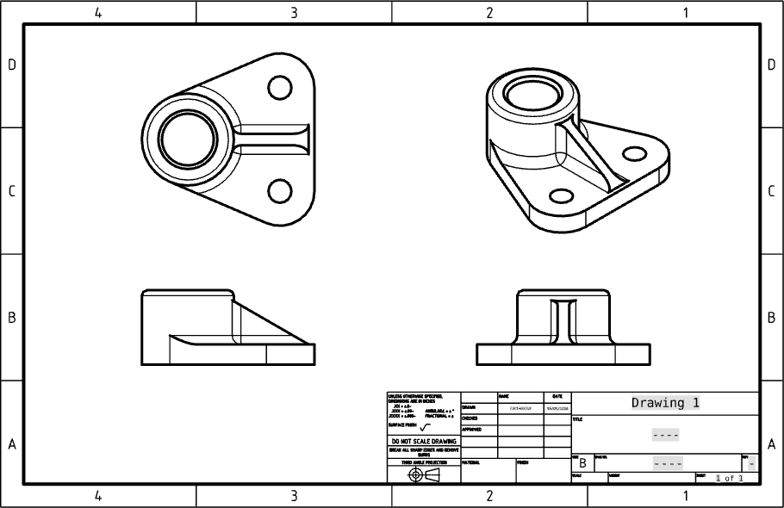

1. Upon second glance it appears that our drawing views are bit too big for our format. Let’s update the scale of our drawing views so there is more room for dimensions. Right-click on the view in the bottom-left corner (our first view) and select “Properties...”. Update the scale as shown:

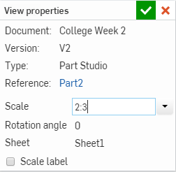

*Pro Tip: The scale is “zoom level” of the views relative to the size of the drawing format. A Scale of 1:1 is a 100% zoom level. If the first number is smaller, like 2:3, then the view is smaller, and if the first number is larger, like 2:1, then the view is larger. It is important to have the views large enough so that the detail of the geometry can be seen clearly, but at the same time they need to be small enough that there is enough white space around the views for dimensions, tolerances, and notes. If the views need to be big to show detail or there are many views on the sheet, then a larger sized format may be needed. When in doubt, go big.*

1. Select the green checkmark, and the entire drawing sheet should update like this:

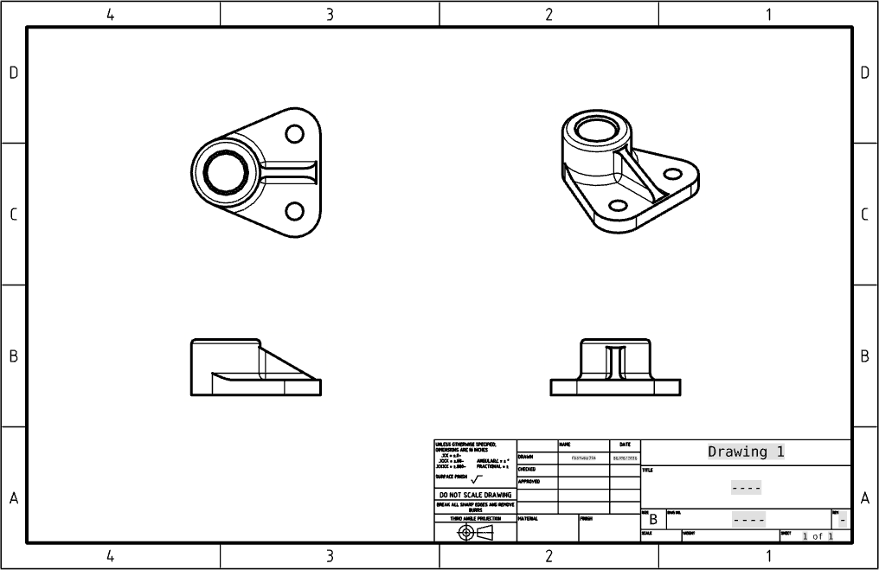

1. Starting with the top left view, let’s add the following dimensions (note that the R0.75 is only two decimals):

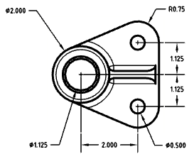

1. In this case, we have two identical holes, so we will add a “2X” prefix to the corresponding dimensions. First, select the following three dimensions:

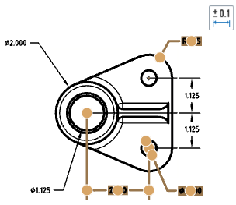

1. Hover over the tolerance icon, and type “2X” in the text box:

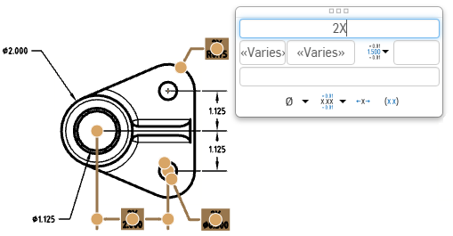

1. The view is now complete, and should look like this:

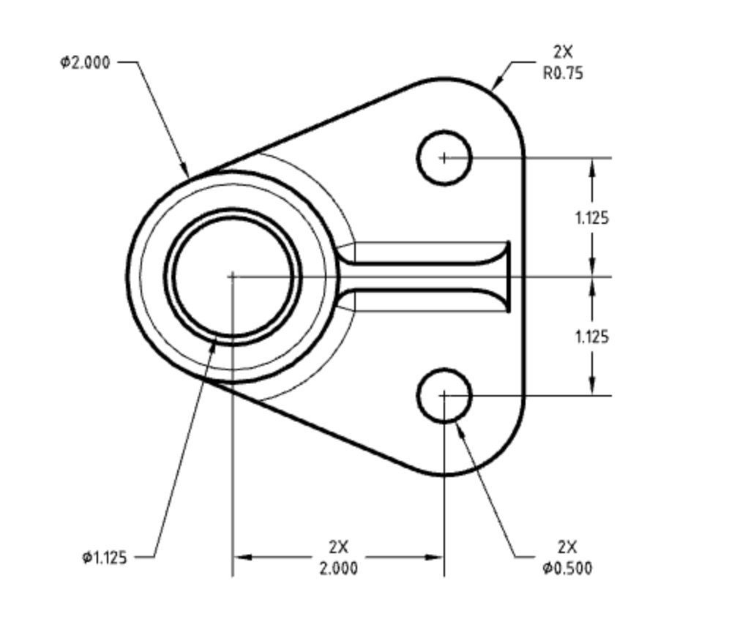

*Pro Tip: In this case, we added a “2X” to the 2.000 dimension, because there are two holes on the right side of the dimension, which are directly above each other. This “2X” note is not mandatory, since it would be implied that the holes are above each other, but in this case it didn’t take us any extra time, and when in doubt, it is better to be too specific, than not specific enough. Remember, mistakes in the machine shop are time consuming and expensive!*

1. Next, let’s dimension the bottom left view. Use the “Line-to-line angular dimension tool”, , for the angle dimension (Note the 0.13 has two decimals):

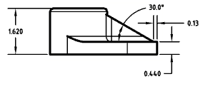

1. Next, let’s add the following dimensions on the bottom-right view (note the number of decimals being used):

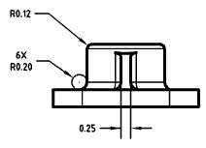

*Pro Tip: Make sure the letter “X” in 6X is capitalized. In fact, all text should be capitalized on an engineering drawing, unless otherwise required. This is defined by ASME Y14.2.*

1. There is one last pair of dimensions missing, do you know which one?

It is the chamfer on the top and bottom of the large bore. There are several ways to dimension this, but for practice (and thoroughness), we are going to create a cross-section view to accomplish this. Click the cross section view icon  and select horizontal:

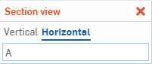

1. Next, hover over the center of the large bore, until a small orange circle is shown. Then click:

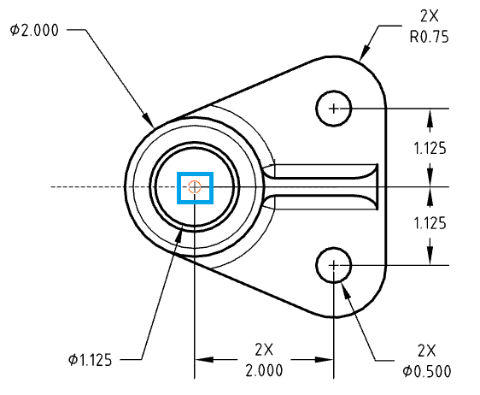

1. Now, place the view at the bottom of the drawing sheet. (Note how the drawing view is automatically named “A-A” and the section view arrows in the main view are also labeled “A”. This naming designation is mandated by ASME Y14.3) :

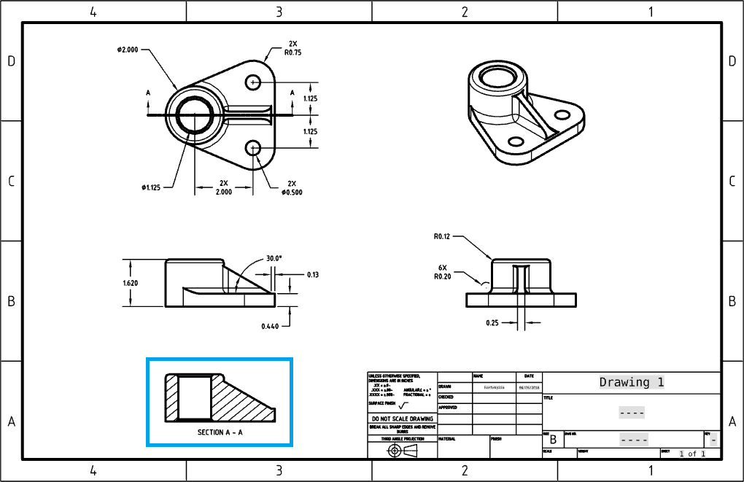

1. Now, we add the following chamfer dimensions (pay attention to the decimals!):

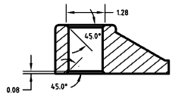

*Pro Tip: Shown above are two different, and equally acceptable methods for dimensioning a chamfer. The top dimension shows the outer diameter, which is easy to measure for inspection, and the bottom dimension shows the depth of the chamfer, which is easy to program into a Computer Numerically Controlled (CNC) machine. If there is doubt which is the preferred method in your situation, ask your local machinist. The best designers in the world are best friends with a machinist!*

1. Congrats, this drawing is now complete!

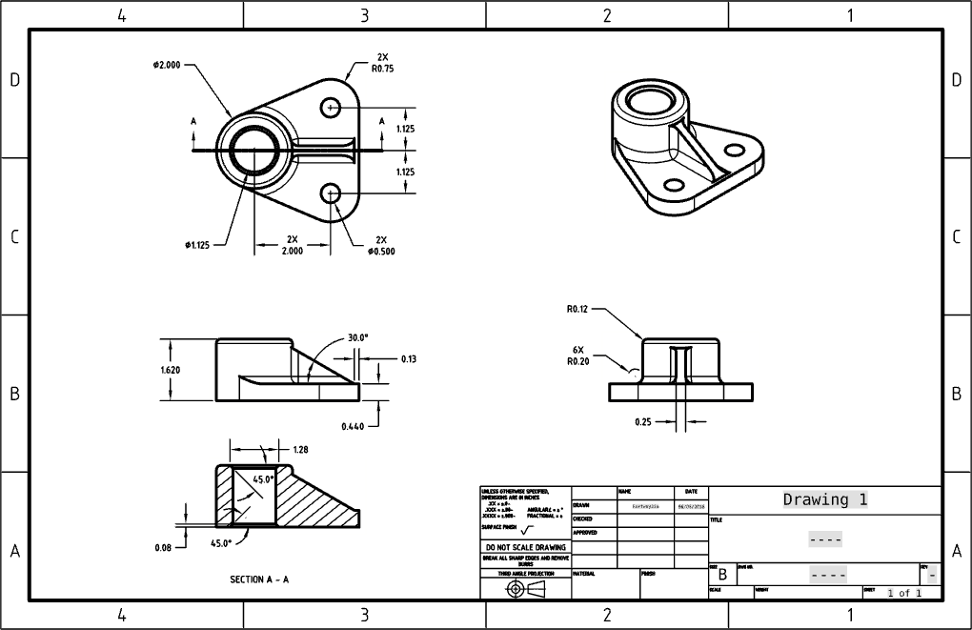

# Detailed View

## In-Class Exercise #3:

1. Let’s get some more practice creating dimensions and tolerances. Using [Part 3 from Week 2](https://docs.google.com/document/d/1NYEj1zOaYX65oQZEZtx-_fqIDtXTgUXqXU_JkwFdm1g/edit#bookmark=id.jby5f454t4fx), recreate the drawing as shown using the ANSI_B_INCH template:

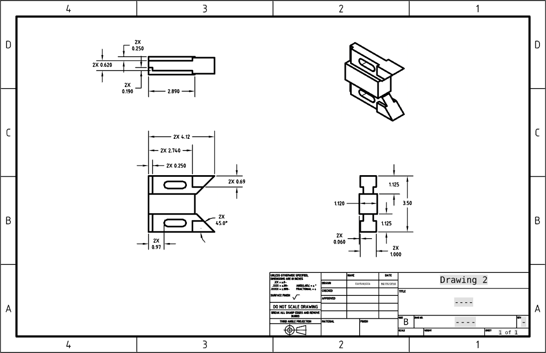

1. Now, if you noticed, we still need to finish locating and detailing the slots. Let’s start by creating a centerline through the slot. Select the centerline tool  and select the two straight edges of the slot:

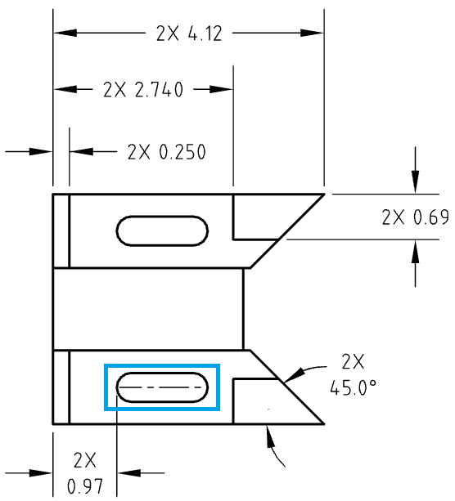

1. Repeat for the top slot, and now we can create vertical dimensions to locate them:

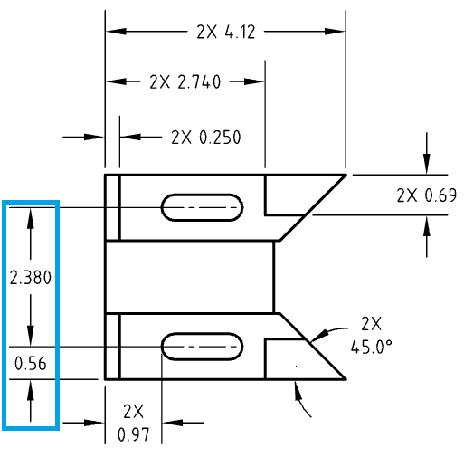

*Pro Tip: Notice how the 2.380 dimension is a tighter tolerance (three decimals) than the 0.56 (two decimals). This is because we are treating these two slots like a hole pattern. Generally speaking, the location of a hole pattern with respect to the outside of a part is a looser tolerance than the dimensions within the pattern itself. This allows the part to be inexpensive and high quality at the same time! This is a relatively advanced design topic. It’s okay if it doesn’t make sense yet, but it is important to highlight details like this because every dimension and tolerance on an engineering drawing has a specific purpose. After some practice, things like this will be second nature!*

1. Next, we need to dimension the slots themselves. Since this view is already quite full with dimensions, let’s use a detail view. Select the detail view icon  and select a point in the middle of the slot to center the view:

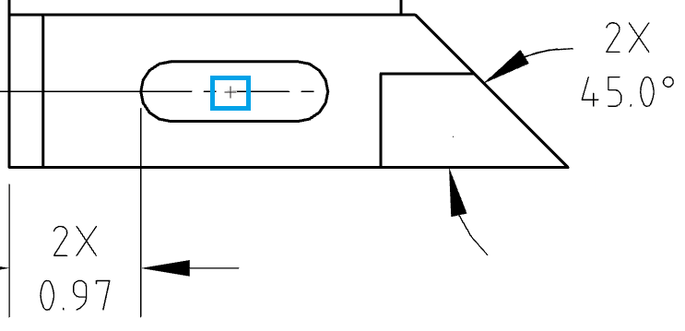

1. Now select a point to define the size of the detail view. Try to choose a point which allows the circle to not intersect with any of the existing geometry or dimensions:

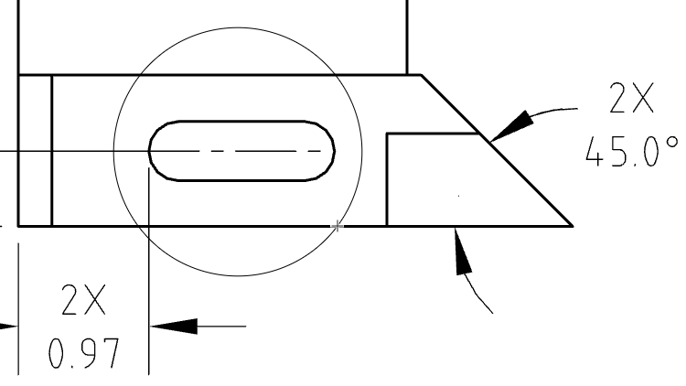

1. Lastly, place the view towards the bottom of the drawing sheet, where this is plenty of open space to put dimensions around the view:

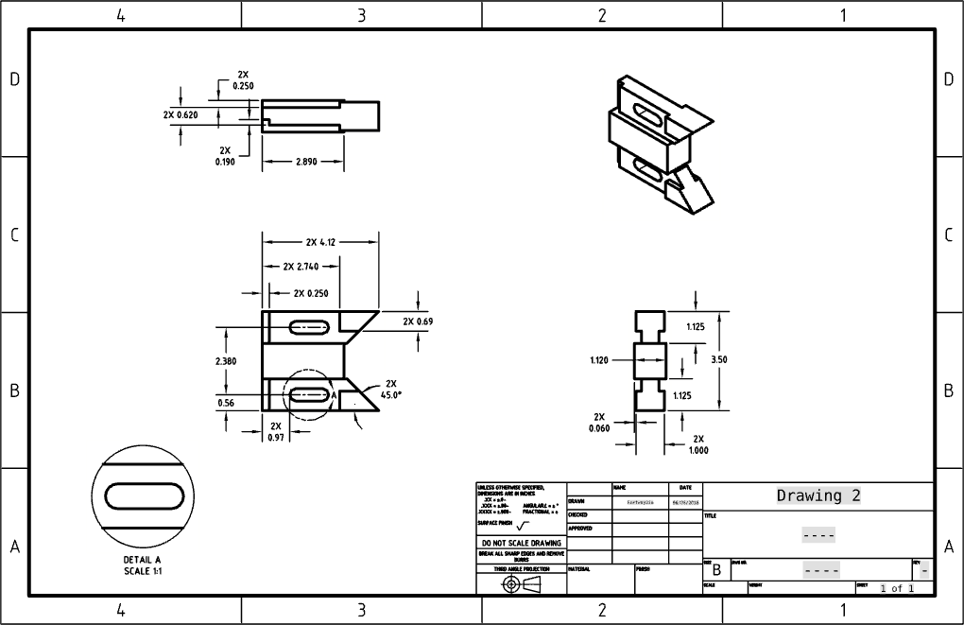

1. Now, let’s dimension the slot (per ASME Y14.5):

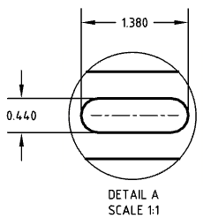

1. Finally, clean up the drawing by (1) making sure the Detail View Letter is outside of the part geometry, (2) adding a centerline, and (3) adding the word “TYPICAL” to the detail view caption by double-clicking on the text box.

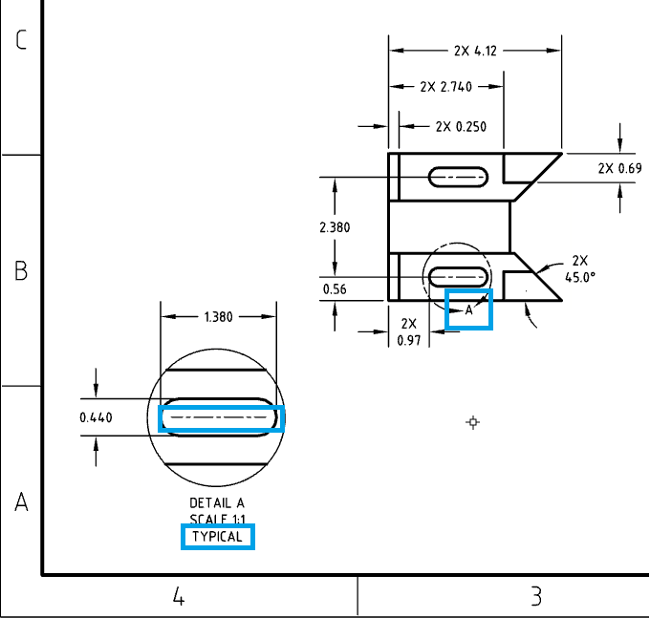

*Pro Tip: “Cleaning up the view” is a common, and sometimes necessary thing to do. We want to make sure the view is easy to read, and not confusing on the eyes. Here we did 3 important things: (1) make sure all text is outside of the part geometry. This is important so the shape of the part can easily be picked up by the eye. (2) adding the centerline makes sure that the slot in the detail is shown exactly as it is in the original view. Consistency is key. (3) Adding the word “TYPICAL” means that the dimensions of this slot are typical to the part (i.e. the other slot is the identical size). This saves us time in having to dimension the other slot as well.*

*Also note that when you move one of the projected views, the rest of the views move as well (except the isometric). This is because Onshape aligns the views such that the edges are aligned:*

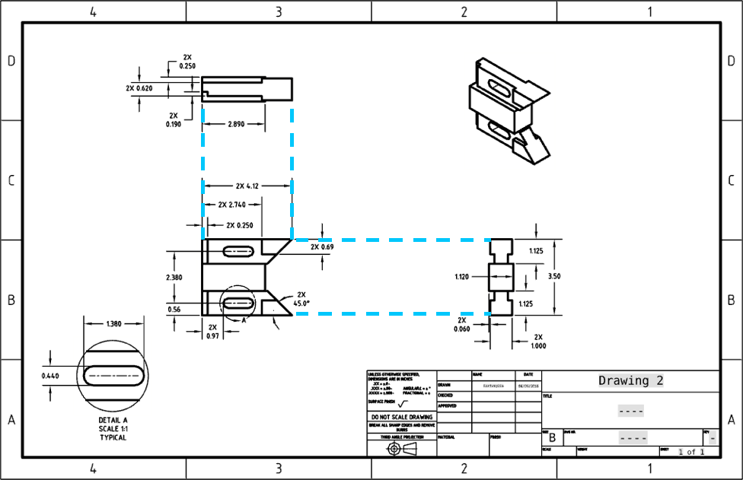

*This is good engineering practice; by doing so, we can know how the views are connected. You can think of it as placing the different views of the model on the corresponding faces of the View Cube and unfolding the View Cube to a flat cube layout.*

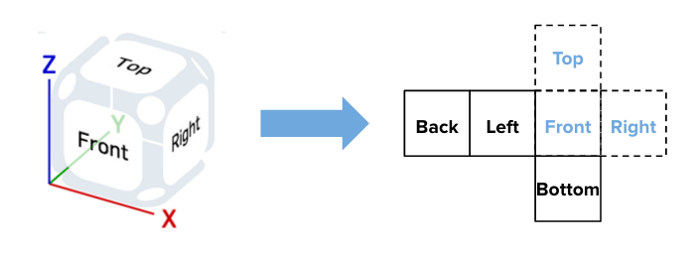

1. The finished drawing should now look like this. Good job!

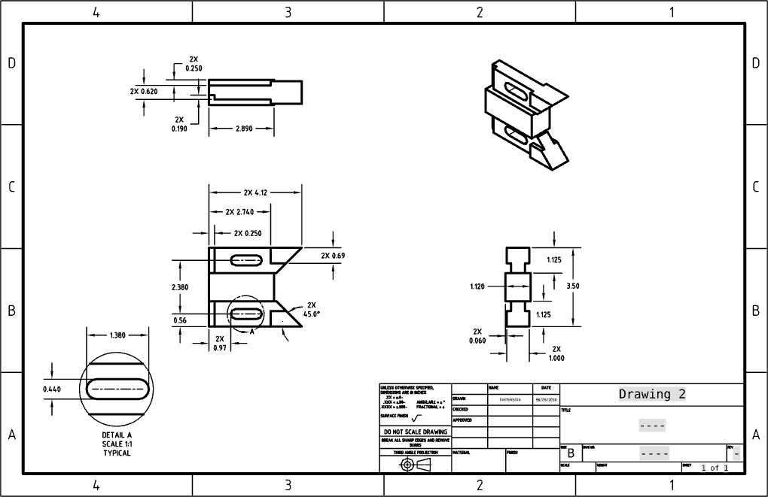

# Auxiliary View

## In-Class Exercise #4:

Using [Part 5 from Week 2](https://docs.google.com/document/d/1NYEj1zOaYX65oQZEZtx-_fqIDtXTgUXqXU_JkwFdm1g/edit#bookmark=id.di16zjgx7gi), let’s create a drawing with an auxiliary view. Auxiliary views are views which are not aligned with any of the primary (Front, Right, Top, etc) directions. In the case of this sheet metal part, there is a face which is bent at a 45° angle, which we will need to dimension.

1. Let’s prepare, by creating the rest of this metric drawing (this means you should select ANSI_B_MM when making the drawing). Once again, keep an eye on the decimals:

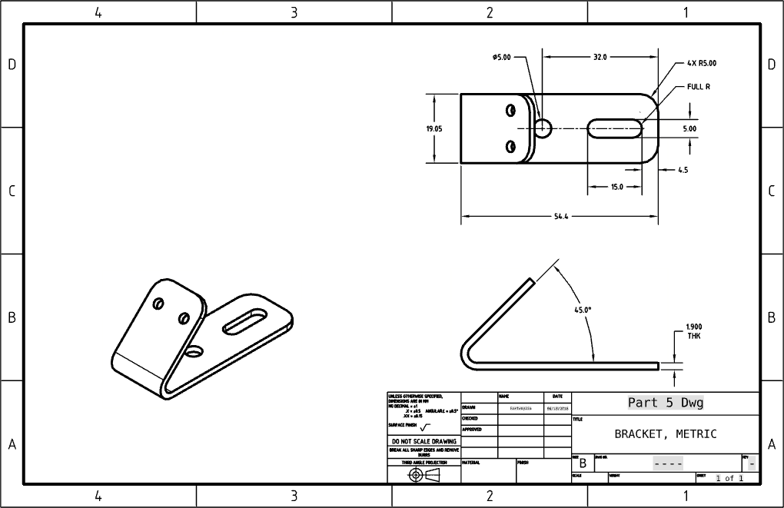

For the text that says “FULL R,” use the “Note with leader” tool . Write the “THK” suffix under the 1.90 dimension similar to how you wrote the “2X” prefixes before.

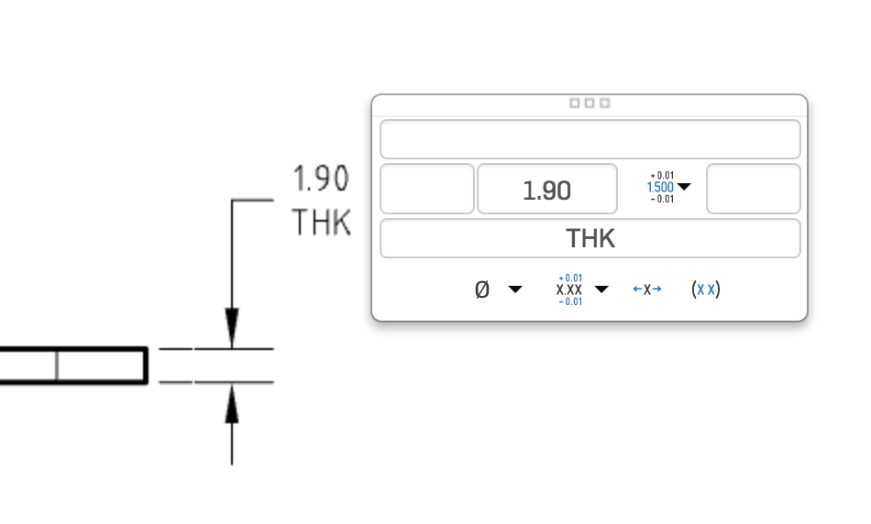

*Pro Tip: We need to update the tolerance block for this metric part. Since millimeters are smaller than inches, the decimal places need to be updated to include a “NO DECIMAL” option, and three decimals is removed here for this sheet metal part. Also, fractions are almost never used in metric (because it is based on tenths, and not twelfths), so that is removed from the tolerance block as well.*

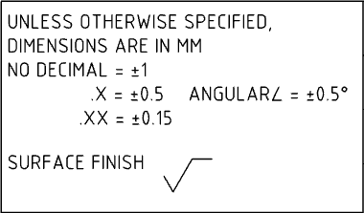

1. Now, let’s select the auxiliary view icon, , and select the 45° edge from the main view:

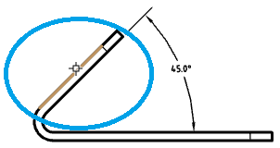

1. Drop the new view in the white space on the sheet. Before we start dimensioning, let’s add centermarks to the two holes we need to dimension:

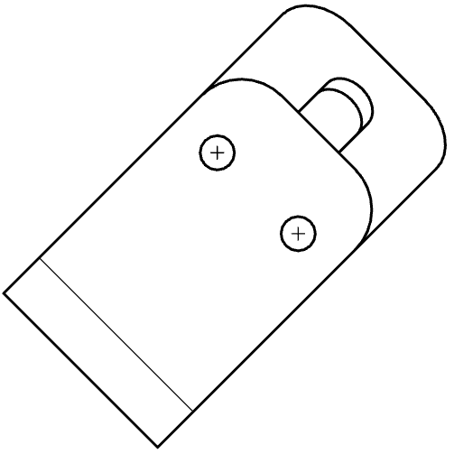

1. Next, let’s dimension the holes. Since the view is at an angle, it is best to use the Point-to-Line Dimension, , and reference the centermarks. This will make sure that the dimensions are aligned with the edges of the part. Also, let’s add the diameter dimension as well:

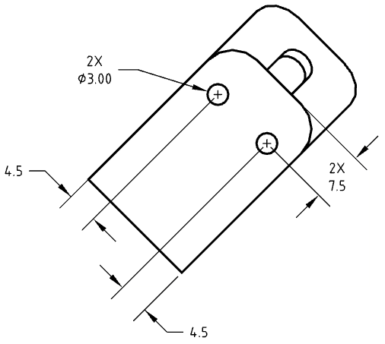

1. Now, using the Line-to-line dimension, , let’s add an overall dimension to the view:

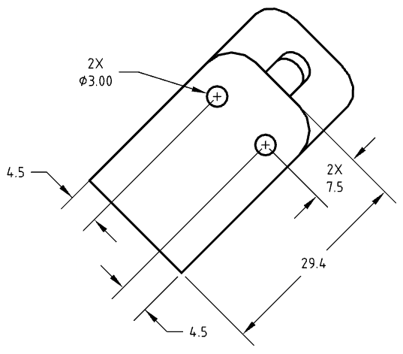

1. Finally, let’s clean up the view by removing the tangent lines on the view. Do this by right-clicking and choosing “Hide tangent lines”. This makes it easier to see face of the part, and to distinguish between the geometry and the leader lines from the dimensions. Good job!

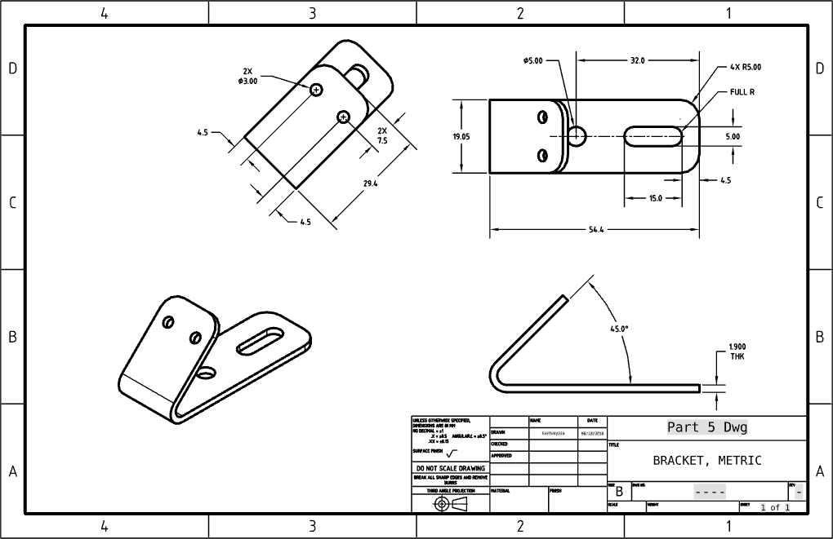

# Geometric Dimensioning & Tolerancing

## In-Class Exercise #5:

Geometric Dimensioning and Tolerancing (as defined by ASME Y14.5M) is a different, more advanced, method of dimensioning and tolerancing geometry, when compared to the traditional “linear” dimension scheme. As before, certain industries and companies have accepted GD&T more so than others. The purpose of this section is to briefly introduce the concepts, as well as how to create the correct GD&T callouts for a certain part.

1. Let’s go back to the drawing we made in [Part 2 from Week 2](https://docs.google.com/document/d/1NYEj1zOaYX65oQZEZtx-_fqIDtXTgUXqXU_JkwFdm1g/edit#bookmark=id.1zhj469efx20), and add some GD&T. Here is what the final drawing will look like, with the new GD&T callouts highlighted in blue:

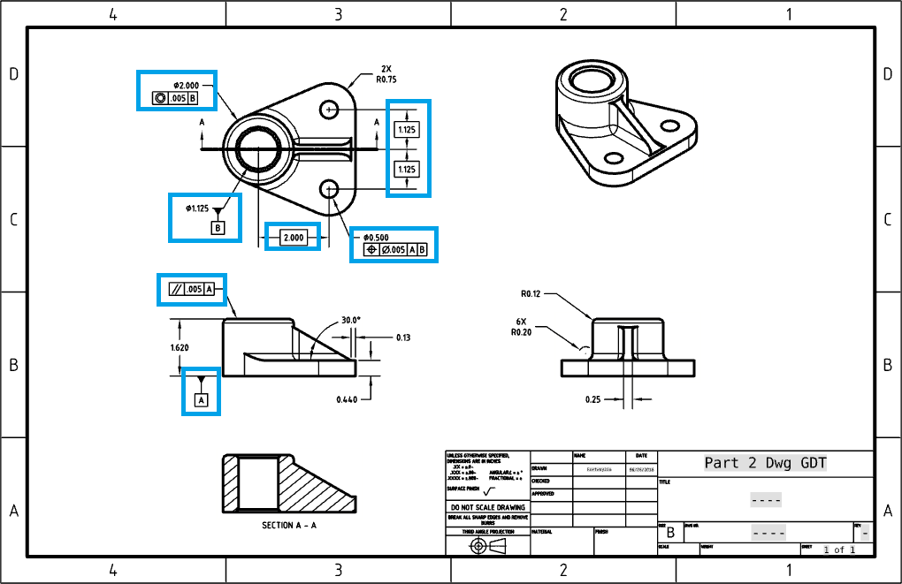

1. First, let’s create the Datums. Datums are surfaces of the part which are critical to its function. These surfaces act as the foundation for the GD&T scheme, and so any GD&T callouts that we add will reference these datums in one way or another. Let’s start by creating Datum A. Select the Datum Tool, , and place the datum on the bottom witness line of the 1.620 dimension (this implies that the bottom surface of the part is Datum A):

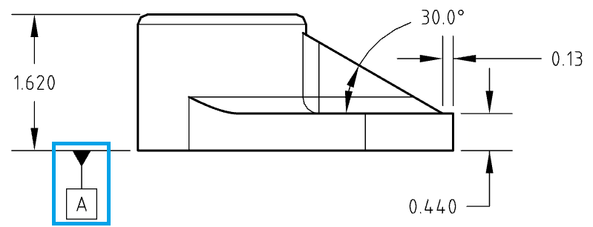

1. Next, let’s add a parallelism callout on the top surface of the part. Start by selecting the Geometric Tolerance icon, . You will be prompted with the Geometric Tolerance dialog. Fill it out like this, then click the green checkmark:

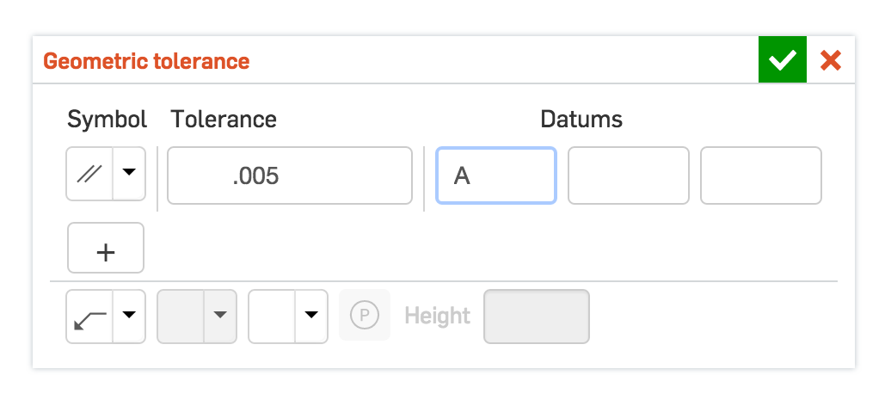

1. Next, click on the top surface of the part to place the arrow, and then click out in the white space to place the annotation:

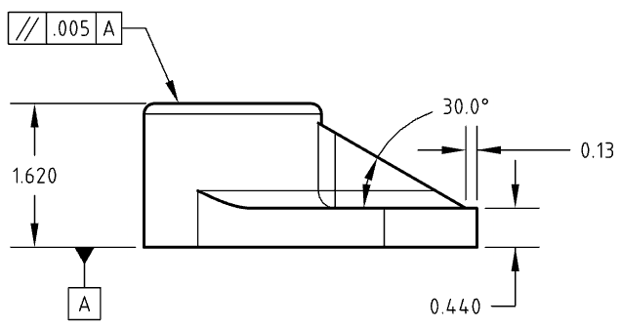

*Pro Tip: So, what does this notation mean? In layman’s terms it says, “this surface must be parallel to Datum A within .005 in”. The reason this might be desired, is that technically one side of that surface could be 1.615 and the other could be 1.625, and the part would be “in spec”, since the original tolerance is 1.620 +/- .005. However, the top and bottom surfaces would be over a degree out of parallel. This might not sound like much, but one degree can add up over a long distance. If, for example, a 12” rotating disc was mounted to this bracket (as sketched below), it would be off by more than a quarter inch on each side. That’s a lot of wobble!*

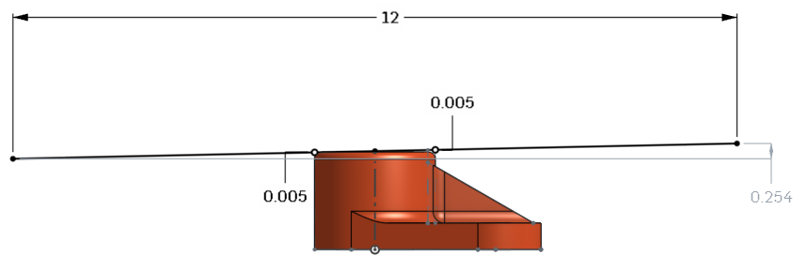

1. Next, let’s add a second datum. This time, we’re going to establish Datum B on the inner surface of the bore. To do this, place the Datum on the 1.125 Diameter dimension as shown:

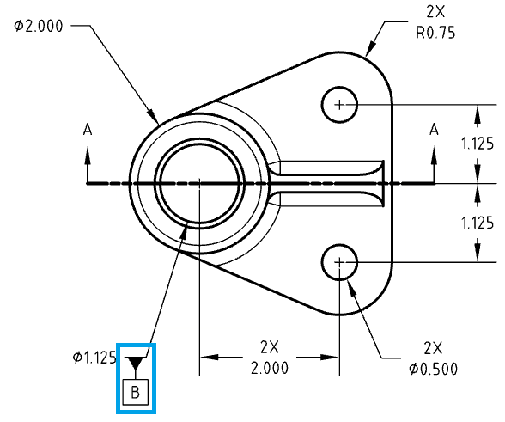

1. Next, let’s create a concentric tolerance, using the same workflow as before. This time place the tolerance just beneath the 2.000 diameter dimension. As you might imagine, this means, “This surface must be concentric to Datum B within .005 in”. :

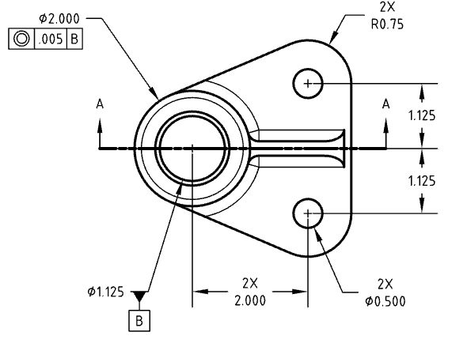

1. Next, let’s create a positional tolerance for the two small holes. To do this, we must first convert the linear dimensions to basic dimensions. This will override the tolerances that are being inherited by the tolerance block of the sheet format. To do this, select the 3 dimensions that locate the holes, expand the Dimension Panel, and select “Basic” from the tolerance pull-down menu. The Dimensions will now have a rectangle around them:

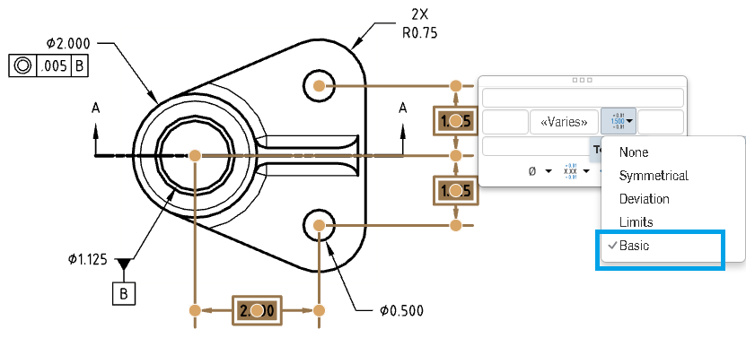

1. Next, create the following Geometric Tolerance:

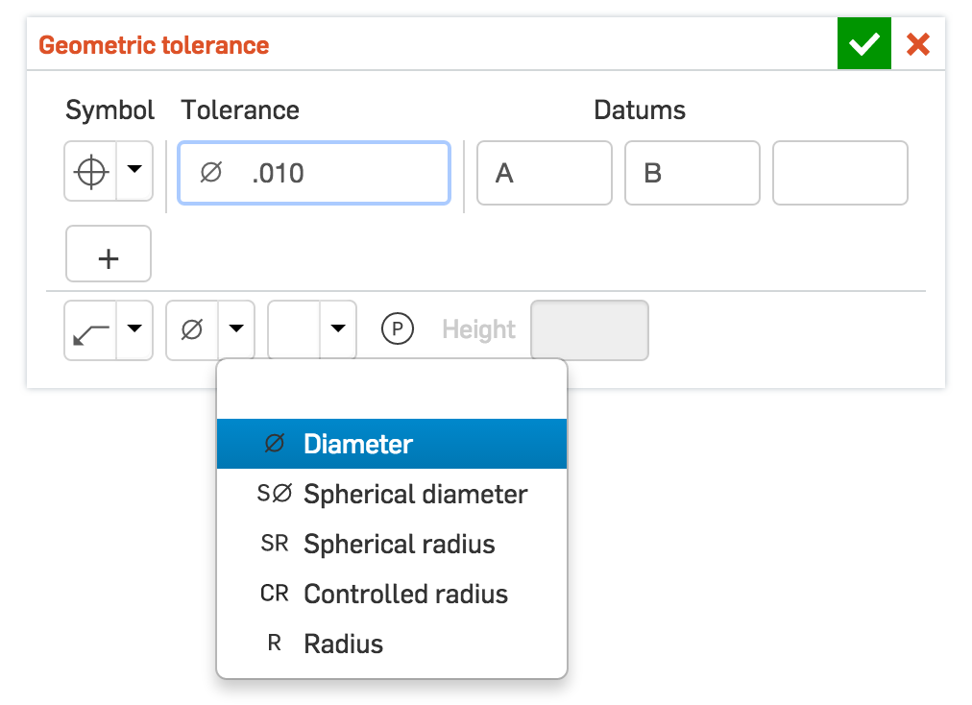

1. Finally, place it just beneath the diameter dimension for the holes. Good Job! The final drawing view should now look like this:

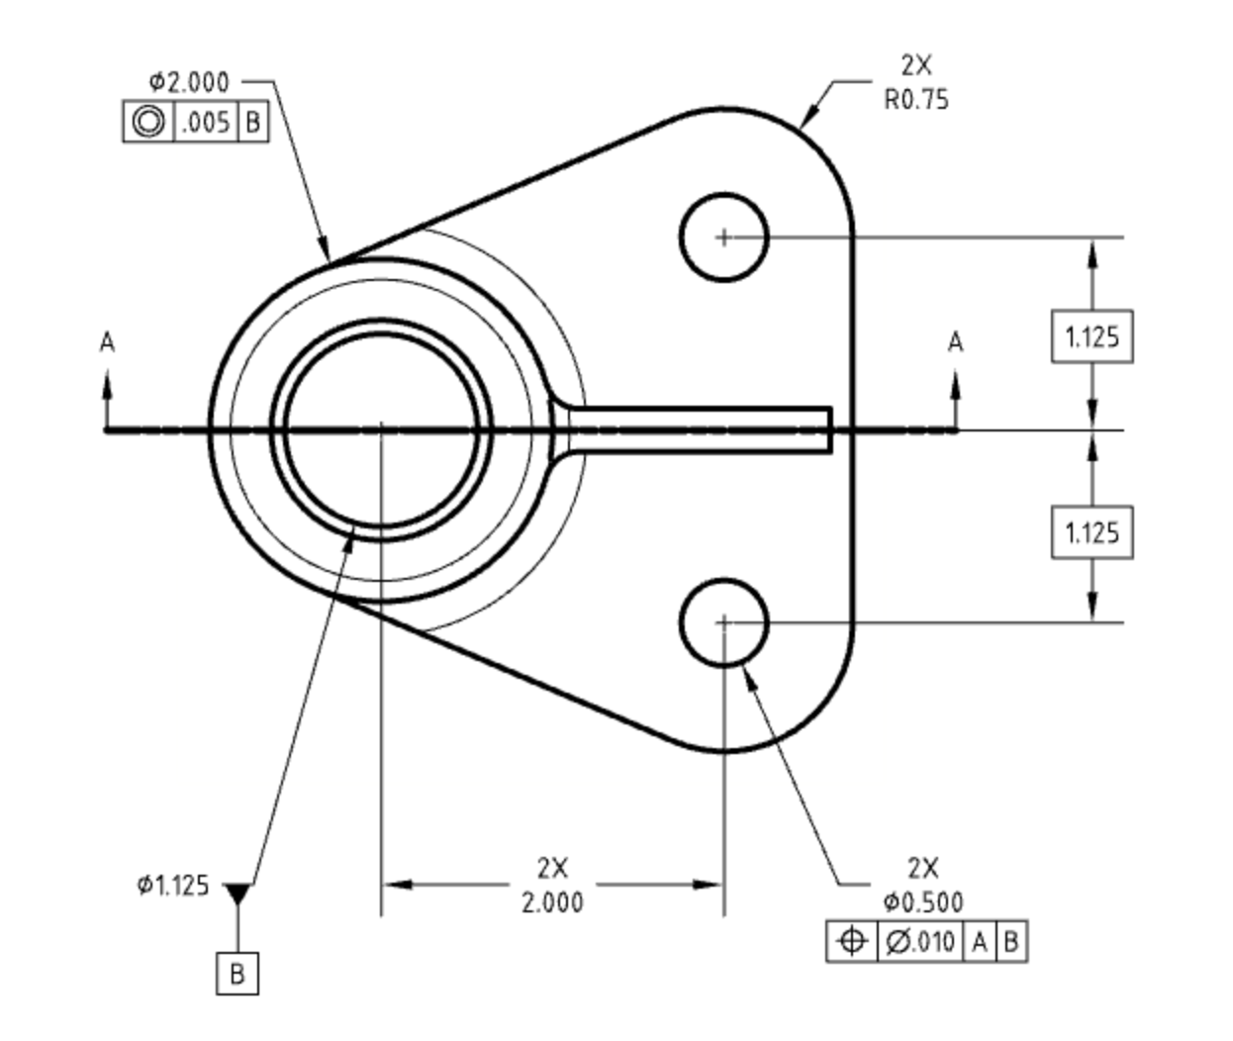

*Pro Tip: This tolerance says, “These holes must be positioned within a .005” circle from the nominal location, with respect to Datums A and B”. To better understand what this means, let’s compare this to the original linear tolerance of +/- .005” in both horizontal and vertical directions. Here is a pictorial showing the tolerance ranges overlaid on top of each other:*

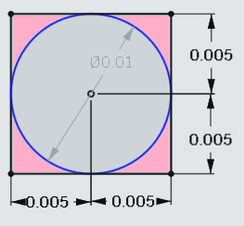

*The original tolerance, shown by a black square, allows the center of the hole to be anywhere within a box that is .01” wide by .01” tall. The geometric tolerance, however, only allows the center of the hole to be within a .01” diameter circle, shown by the blue circle. This means that the geometric tolerance is “tighter”, since it won’t allow the center of the hole to be in the pink shaded areas, whereas the original linear tolerances would.*

*In addition, when we say “with respect to Datums A and B”, we are referring to the datums that would be used to inspect this tolerance in a production/quality control environment. Datum A is the surface of the part that would be rested on the inspection table, and Datum B is the surface that the holes are measured from.*

*Great job! These are very advanced topics, so fully understanding them is not critical at this time in order to become a proficient designer in Onshape. Again, this is not meant to be a comprehensive lesson on GD&T, but rather an introduction to how (and why) you would utilize GD&T in Onshape.*

# Assembly Drawings

There are a number of reasons why we create Assembly drawings, but for the most part we are communicating how an assembly is built. In its simplest form, an Assembly drawing shows a single view, with Balloon callouts to each individual part. As assemblies get more complex, there can be many views, notes for adhesives & lubricants, torque specifications for fasteners, and cross references to manufacturing fixtures, tools, or even quality control documents. Generally speaking an Assembly print has more notes and balloons and less dimensions than a part drawing. Again, each industry and company has it’s own specific standards, and this curriculum is designed to just give an introductory lesson on how to build simple assembly drawings in Onshape.

## In-Class Exercise #6:

Create the following Assembly Drawing using the Vise Assembly by looking for it under “Browse documents”. Balloons, which are unique notes that reference individual parts, are created with the balloon tool, , found in the Drawing Toolbar. Write “2X” to signify the two bolts using the Note tool :

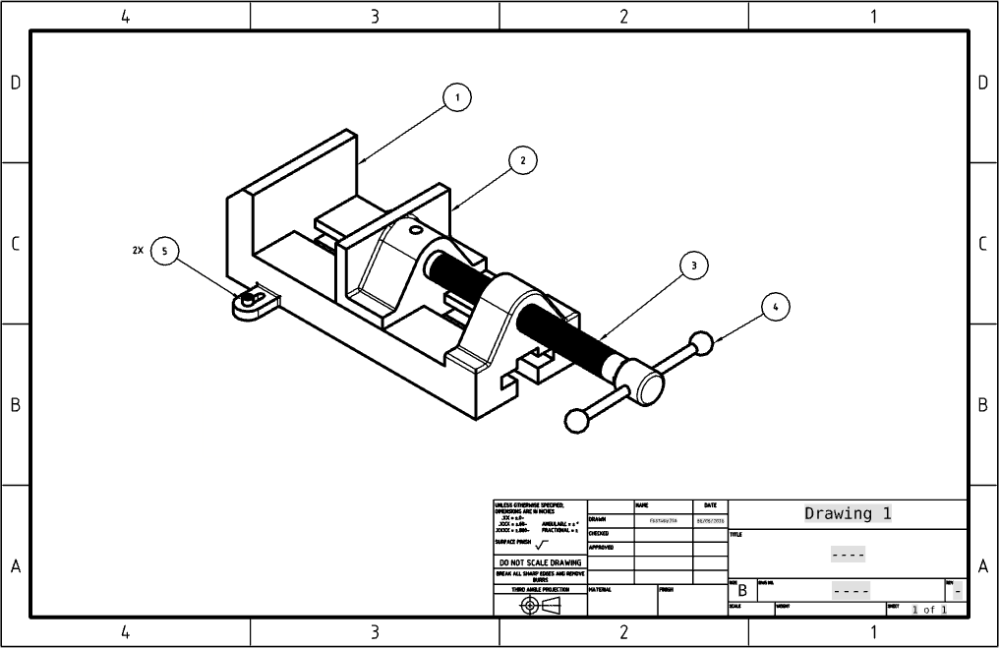

## 

# Printing Drawings, Part Studios and Assemblies

As mentioned before, Engineering Drawings are sometimes called “Prints”, for when they are actually printed out. Although, hard copies are becoming less common, it is still very important to be able to print out a drawing to show others, markup with your favorite red marker, or to frame and hang on the wall with pride.

1. To print a Drawing from within Onshape, expand the document menu and select “Print…”:

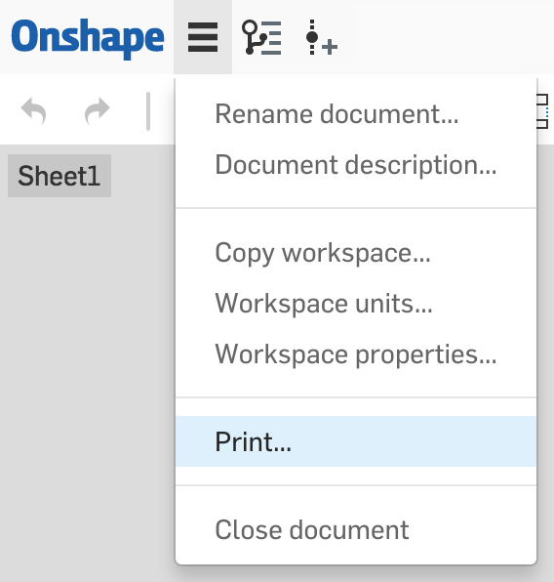

1. A new tab will open up in the active browser with a print-friendly version of the document. From here, follow the prompts for printing.
2. In addition, you can also print any Part Studio or Assembly in Onshape. Open the tab you wish to print, expand the Document menu, and select “Print…” just as with a drawing. A Print dialog pops up with paper size and orientation options, and a convenient dotted line appears to help position the model for printing:

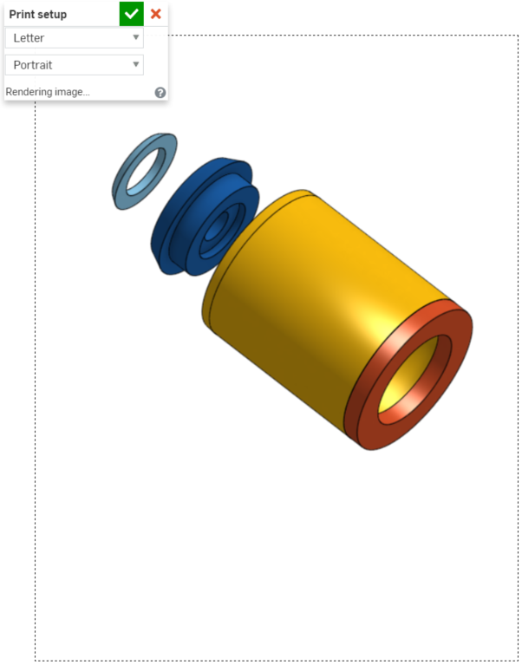

1. You can click and drag the items (parts, models, drawings) to position it within the dotted page borders using Onshape mouse actions for moving parts.
2. Select the desired paper size.
3. Select Portrait or Landscape orientation.
4. When satisfied with the setup of the page, click  to display the page as it will be printed (print preview):

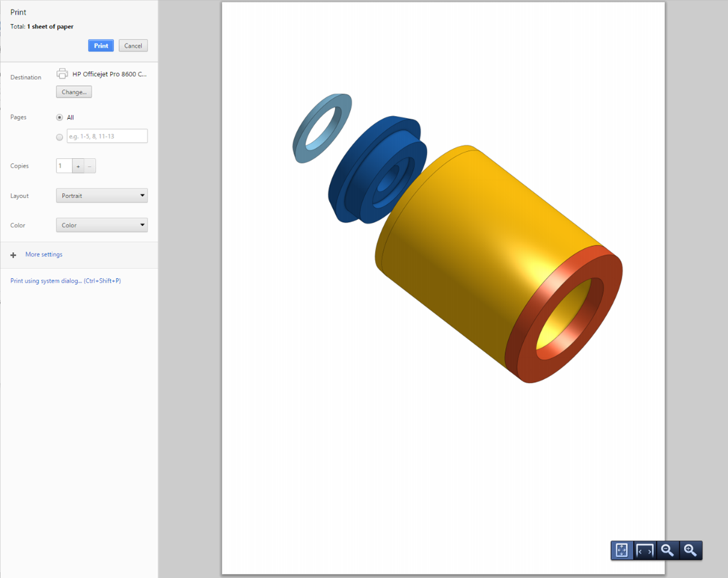

1. Make specifications and click **Print**.

# Updating Drawings

*Pro Tip: There is an important, but somewhat subtle functionality with drawings that should be discussed, and that is in regard to updating drawings. In traditional CAD tools, the drawing is always updated to the latest CAD model by default. Any formal changes are then tracked with a “business process”, either via manual paper documents (called Engineering Change Orders, or ECO’s for short), or a digital Product Data Management (PDM) or Product Lifecycle Management (PLM) software program. The majority of companies utilize a business process that includes both a digital PDM system and a manual paper ECO process for redundancy.*

*In Onshape, however, there is no formal PDM system. Since the Onshape platform is 100% cloud based, it does not need one. As a result, automatically updating the Engineering Drawing to the latest version of the CAD model is not desired. Instead, the Engineering Drawing must explicitly be updated, using the Update Drawing icon,* *. In most cases it is greyed out (as previously shown), but when the CAD model has been changed, the icon lights up like this:* *. Updating the drawing may take some time, and cannot be undone, so be sure that it is necessary before doing it.*

*More information can be found here:* [*https://cad.onshape.com/help/#drawings-updating.htm*](https://cad.onshape.com/help/#drawings-updating.htm)

# Summary

Let’s take a second to reflect what we learned in this lesson.

1. We learned that you can make Engineering Drawings by selecting “Create drawing…” in the tabs on the bottom of the screen.
2. You can add linear and angular dimensions to your Drawings.
3. You can choose to add projected, section, or auxiliary views to your Drawings.
4. Each dimension has an associated tolerance, which determines how accurate your part should be during manufacturing.
5. You can add detailed views and annotations to your Drawings.
6. Geometry Dimensioning and Tolerancing (GD&T*)* is an advanced drawing method that many companies use in their Engineering Drawings.
7. You can also create Assembly Drawings.

Next week, we’re going to start our first major project, the Bluetooth Speaker. Make sure to brush up on everything we’ve learned so far!